**100 Java Programs**

**Contents**

**Java Programs** .............................................................................................................................................................................. 1

1. **Simple Java Program.** ....................................................................................................................................................... 4
2. **Print Integer in java** ............................................................................................................................................................ 4
3. **Command Line Argument** ................................................................................................................................................ 4
4. **How to get Using input using Scanner Program in java** ........................................................................................ 5
5. **How to convert Fahrenheit to Celsius Program in java** ....................................................................................... 5
6. **How to swap 2 no using 3rd variable Program in java** ............................................................................................ 6
7. **How to swap 2 no without using 3rd variable Program in java** ............................................................................. 6
8. **How to add two number Program in java** ................................................................................................................... 7
9. **Find Largest no in java Program** ................................................................................................................................... 8
10. **If Else clause in java** ..................................................................................................................................................... 8
11. **If Else clause in java- Program 2** ............................................................................................................................... 9
12. **Nested If Else clause in java** ....................................................................................................................................... 9
13. **How to check Odd and Even Number in java.** ...................................................................................................... 10
14. **Find factorial for given no Program in Java** ......................................................................................................... 10
15. **How to complete 2 string in Java program** .......................................................................................................... 11
16. **Simple For Loop Program in Java** ......................................................................................................................... 12
17. **Print Star console using Loop** ................................................................................................................................. 12
18. **Print Star console using Loop** ................................................................................................................................. 13
19. **While loop Program in java** ....................................................................................................................................... 13
20. **Print Reverse number in java program** ................................................................................................................. 14
21. **While loop using break Program in java** .............................................................................................................. 14
22. **While loop using break and continue Program in java** ...................................................................................... 15
23. **Print all alphabet using for loop Program in java**................................................................................................ 15
24. **Enhance loop in java Program** ................................................................................................................................ 16
25. **Print Multiplication table Program in java** ............................................................................................................ 16
26. **Print prime no Program in java** ............................................................................................................................... 17
27. **Check no is Armstrong or not in java Program** ................................................................................................. 18
28. **Print Floyd’s Triangle in java Program** ................................................................................................................ 19
29. **Find All substring of string in java Program** ........................................................................................................ 19

Automation Proficient

1. **Print reverse string in java Program** ..................................................................................................................... 20
2. **Check Given No is palindrome or Not in java Program** .................................................................................... 21
3. **How to add two matrix in java Program** ................................................................................................................. 22
4. **How to multiply two matrix in java Program**......................................................................................................... 23
5. **How to get transpose of matrix in java Program** ................................................................................................ 24
6. **How to compare 2 string in java Program** ............................................................................................................ 25
7. **How to string width with specific char in java Program** ................................................................................... 25
8. **How to use indesOf() in java Program** .................................................................................................................. 25
9. **How to replace string with another string in java Program** ............................................................................. 26
10. **How to split string in java Program** ........................................................................................................................ 26
11. **How to remove space in string both end in java Program**................................................................ ................ 26
12. **How to convert all char in string lower case in java Program** ......................................................................... 26
13. **How to create method in java Program** ................................................................................................................ 27
14. **Find Length, Concatenate and Replace String in Java Program** ................................................................... 27
15. **How Static block working in java Program** ........................................................................................................... 28
16. **Difference between Static and Instance method working in java Program** ................................................. 28
17. **How to create Multiple class in java Program** ..................................................................................................... 29
18. **How to create constructor in java Program** ......................................................................................................... 29
19. **How to create constructor overloading in java Program** ................................................................................. 30
20. **Exception Handling java Program**........................................................................................................................... 30
21. **How to throw exception in java Program** ............................................................................................................. 31
22. **Advantage of Finally in Exception Handling java Program** ............................................................................. 31
23. **How to create Interface in java Program** .............................................................................................................. 32
24. **How to print date and time in java Program** ........................................................................................................ 32
25. **How to SQL Date in java Program**................................ .......................................................................................... 33
26. **How to Date format in java Program** .................................................................................................................... 33
27. **How to Generate random number in java Program** ........................................................................................... 34
28. **How perform garbage collection in java Program** ............................................................................................. 34
29. **How to get own IP Address in java Program**................................ ....................................................................... 34
30. **How to open notepad in java Program**.................................................................................................................. 35
31. **Leaner search Program in java** ............................................................................................................................... 35
32. **Binary search Program in java** ................................................................................................................................ 36
33. **Bubble sort Program in java** .................................................................................................................................... 37
34. **How to connect Database using java Program** .................................................................................................... 37
35. **How to insert data in table using JDBC in java Program** ................................................................................ 38
36. **How to insert image using JDBC in java Program** ............................................................................................ 38
37. **How to execute Procedure in JDBC in java Program**....................................................................................... 39 Automation Proficient
38. **How to check Regular expression in java Program** .......................................................................................... 39
39. **How to create Multithreading program in java** ..................................................................................................... 39
40. **How to join thread in java program** ....................................................................................................................... 40
41. **How to write data in text file using java program** ............................................................................................... 40
42. **How to read data from text file using java program** .......................................................................................... 40
43. **How to get URL of site using java Programs** ....................................................................................................... 41
44. **How to get IP address from site URL using java program** ................................................................................ 41
45. **How to create AWT program in java** ....................................................................................................................... 41
46. **How to add lable in AWT program in java** ............................................................................................................ 42
47. **How to add text area program in java** .................................................................................................................... 42
48. **How to dropdown in AWT program in java** ........................................................................................................... 42
49. **How to create Swing program in java** ................................................................................................................... 43
50. **How to add checkbox in Swing program in java** ................................................................................................. 43
51. **How to convert string to integer in java program** .............................................................................................. 44
52. **How to convert integer to string in java program** .............................................................................................. 44
53. **How to convert string to long in java** ..................................................................................................................... 44
54. **How to convert string to float in java** ..................................................................................................................... 44
55. **How to convert string to double in java program**................................................................................................ 44
56. **How to convert string to date in java program** ................................................................................................... 45
57. **Create ArrayList program in java** ......................................................................................................................... 45
58. **How to create LinkedList program in java** ............................................................................................................ 46
59. **How to ArrayList using list interface program in java** ....................................................................................... 46
60. **How to create Hashset program in java** ................................................................................................................. 47
61. **How to create LinkedHashSet program in java** ................................................................................................... 47
62. **How to create TreeSet program in java**.................................................................................................................. 48
63. **How to create PriorityQueue program in java** ...................................................................................................... 48
64. **How to create HashMap using map interface program in java** ........................................................................ 49
65. **How to create LinkedHashMap program in java** ................................................................................................. 49
66. **How to create TreeMap program in java** ................................................................................................................ 49
67. **How to create Hashtable program in java** ............................................................................................................. 50
68. **How to create Array program in java** ...................................................................................................................... 50
69. **How to create Multidimensional array program in java** ..................................................................................... 50
70. **How to create Find Factorial No using Recursion Program in java** .............................................................. 51
71. **How to create Method Overriding program in java** ............................................................................................. 51

# Automation Pro ficient

**1. Simple Java Program**

**class** HelloWorld

{

**public** **static** **void** main(String args[])

{

System.out.println("Hello World by Technolamror");

}

}

# 2. Print Integer in java

**class**

Integers

{

**public**

**static**

**void**

main

(

String

[]

arguments

)

{

**int**

c

;

*//declaring a variable*

*/* Using for loop to repeat instruction execution */*

**for**

(

c

=

1

;

c

<=

10

;

c

++

)

{

System

.

out

.

println

(

c

)

;

}

}

}

# 3. Command Line Argument in java

**class** Arguments {

**public** **static** **void** main(String[] args) { **for** (String t: args) { System.out.println(t);

}

} }

**Automation Proficient**

# 4. How to get Using input using Scanner Program in java

**import** java.util.Scanner;

**class** GetInputFromUser

{

**public**

**static**

**void**

main

(

String

args

[])

{

**int**

a

;

**float**

b

;

String

s

;

Scanner in

=

**new**

Scanner

(

System

.

in

)

;

System

.

out

.

println

(

"Enter a string"

)

;

s

=

in.

nextLine

()

;

System

.

out

.

println

(

"You entered string "

+

s

)

;

System

.

out

.

println

(

"Enter an integer"

)

;

a

=

in.

nextInt

()

;

System

.

out

.

println

(

"You entered integer "

+

a

)

;

System

.

out

.

println

(

"Enter a float"

)

;

b

=

in.

nextFloat

()

;

System

.

out

.

println

(

"You entered float "

+

b

)

;

}

}

# 5. How to convert Fahrenheit to Celsius Program in java

**import** java.util.*;

**class** FahrenheitToCelsius { **public** **static** **void** main(String[] args) { **float** temperatue;

Scanner in = **new** Scanner(System.in);

System.out.println("Enter temperatue in Fahrenheit"); temperatue = in.nextInt();

temperatue = ((temperatue - 32)*5)/9;

System.out.println("Temperatue in Celsius = " + temperatue); }

}

## Automation Pro ficient

# 6. How to swap 2 no using 3rd variable Program in java

**import**

java.util.Scanner

;

**class**

SwapNumbers

{

**public**

**static**

**void**

main

(

String

args

[])

{

**int**

x, y, temp

;

System

.

out

.

println

(

"Enter x and y"

)

;

Scanner in

=

**new**

Scanner

(

System

.

in

)

;

x

=

in.

nextInt

()

;

y

=

in.

nextInt

()

;

System

.

out

.

println

(

"Before Swapping

**\n**

x = "

+

x

+

"

**\n**

y = "

+

y

)

;

temp

=

x

;

x

=

y

;

y

=

temp

;

System

.

out

.

println

(

"After Swapping

**\n**

x = "

+

x

+

"

**\n**

y = "

+

y

)

;

}

}

# 7. How to swap 2 no without using 3rd variable Program in java

**import** java.util.Scanner;

**class** SwapNumbers

{

**public** **static** **void** main(String args[])

{ **int** x, y;

System.out.println("Enter x and y");

Scanner in = **new** Scanner(System.in);

x = in.nextInt(); y = in.nextInt();

System.out.println("Before Swapping**\n**x = "+x+"**\n**y = "+y);

## Automation Pro ficient

x = x + y; y = x - y; x = x - y;

System.out.println("After Swapping**\n**x = "+x+"**\n**y = "+y);

}

}

# 8. How to add two number Program in java

**import** java.util.Scanner;

System.out.println("Enter second large number"); number2 = in.nextLine();

**class**

AddNumbers

{

**public**

**static**

**void**

main

(

String

args

[])

{

**int**

x, y, z

;

System

.

out

.

println

(

"Enter two integers to calculate their sum "

)

;

Scanner in

=

**new**

Scanner

(

System

.

in

)

;

x

=

in.

nextInt

()

;

y

=

in.

nextInt

()

;

z

=

x

+

y

;

System

.

out

.

println

(

"Sum of entered integers = "

+

z

)

;

}

}

//For Large Number

**import**

java.util.Scanner

;

**import**

java.math.BigInteger

;

**class**

AddingLargeNumbers

{

**public**

**static**

**void**

main

(

String

[]

args

)

{

String

number1, number2

;

Scanner in

=

**new**

Scanner

(

System

.

in

)

;

System

.

out

.

println

(

"Enter first large number"

)

;

number1

=

in.

nextLine

()

;

BigInteger first = **new** BigInteger(number1);

BigInteger second = **new** BigInteger(number2);

BigInteger sum;

sum = first.add(second);

System.out.println("Result of addition = " + sum);

}

## Automation Prof icient

}

# 9. Find Largest no in java Program

**import** java.util.Scanner;

**class** LargestOfThreeNumbers

{

**public** **static** **void** main(String args[])

{ **int** x, y, z;

System.out.println("Enter three integers ");

Scanner in = **new** Scanner(System.in);

x = in.nextInt(); y = in.nextInt(); z = in.nextInt();

**if** ( x > y && x > z )

System.out.println("First number is largest."); **else** **if** ( y > x && y > z )

System.out.println("Second number is largest."); **else** **if** ( z > x && z > y )

System.out.println("Third number is largest."); **else**

System.out.println("Entered numbers are not distinct.");

}

}

# 10. If Else clause in java

**class** Condition {

**public** **static** **void** main(String[] args) { **boolean** learning = **true**;

**if** (learning) {

System.out.println("Java programmer");

} **else** {

System.out.println("What are you doing here?");

}

}

}

## Automation Prof icient

# 11. If Else clause in java- Program 2

*// If else in Java code*

**import**

java.util.Scanner

;

**class**

IfElse

{

**public**

**static**

**void**

main

(

String

[]

args

)

{

**int**

marksObtained, passingMarks

;

passingMarks

=

40

;

Scanner input

=

**new**

Scanner

(

System

.

in

)

;

System

.

out

.

println

(

"Input marks scored by you"

)

;

marksObtained

=

input.

nextInt

()

;

**if**

(

marksObtained

>=

passingMarks

)

{

System

.

out

.

println

(

"You passed the exam."

)

;

}

**else**

{

System

.

out

.

println

(

"Unfortunately you failed to pass the exam."

)

;

}

}

}

# 12. Nested If Else clause in java

**import**

java.util.Scanner

;

**class**

NestedIfElse

{

**public**

**static**

**void**

main

(

String

[]

args

)

{

**int**

marksObtained, passingMarks

;

**char**

grade

;

passingMarks

=

40

;

Scanner input

=

**new**

Scanner

(

System

.

in

)

;

System.out.println("Input marks scored by you");

marksObtained = input.nextInt();

**if** (marksObtained >= passingMarks) {

**if** (marksObtained > 90) grade = 'A';

**else** **if** (marksObtained > 75) grade = 'B'; **else** **if** (marksObtained > 60) grade = 'C'; **else**

grade = 'D';

System.out.println("You passed the exam and your grade is " + grade);

} **else** { grade = 'F';

System.out.println("You failed and your grade is " + grade);

}

}

}

**13. How to check Odd and Even Number in java.**

**import**

java.util.Scanner

;

**class**

OddOrEven

{

**public**

**static**

**void**

main

(

String

args

[])

{

**int**

x

;

System

.

out

.

println

(

"Enter an integer to check if it is odd or even "

)

;

Scanner in

=

**new**

Scanner

(

System

.

in

)

;

x

=

in.

nextInt

()

;

**if**

(

x

%

2

==

0

)

System

.

out

.

println

(

"You entered an even number."

)

;

**else**

System

.

out

.

println

(

"You entered an odd number."

)

;

}

}

# 14. Find factorial for given no Program in Java

**import** java.util.Scanner;

**class** Factorial

{

**public** **static** **void** main(String args[])

{

**int** n, c, fact = 1;

System.out.println("Enter an integer to calculate it's factorial");

Scanner in = **new** Scanner(System.in);

n = in.nextInt();

**if** ( n < 0 )

System.out.println("Number should be non-negative."); **else**

{

**for** ( c = 1 ; c <= n ; c++ ) fact = fact*c;

System.out.println("Factorial of "+n+" is = "+fact);

}

}

}

//

**Calculate factorial for large No**

**import**

java.util.Scanner

;

**import**

java.math.BigInteger

;

**class**

BigFactorial

{

**public**

**static**

**void**

main

(

String

args

[])

{

**int**

n, c

;

BigInteger

inc

=

**new**

BigInteger

(

"1"

)

;

BigInteger

fact

=

**new**

BigInteger

(

"1"

)

;

Scanner input

=

**new**

Scanner

(

System

.

in

)

;

System

.

out

.

println

(

"Input an integer"

)

;

n

=

input.

nextInt

()

;

**for**

(

c

=

1

;

c

<=

n

;

c

++

)

{

fact

=

fact.

multiply

(

inc

)

;

inc

=

inc.

add

(

BigInteger

.

ONE

)

;

}

System

.

out

.

println

(

n

+

"! = "

+

fact

)

;

}

}

# 15. How to complete 2 string in Java program

**import** java.util.Scanner;

**class** CompareStrings

{

**public** **static** **void** main(String args[])

{

String s1, s2;

Scanner in = **new** Scanner(System.in);

System.out.println("Enter the first string"); s1 = in.nextLine();

System.out.println("Enter the second string"); s2 = in.nextLine();

**if** ( s1.compareTo(s2) > 0 )

System.out.println("First string is greater than second."); **else** **if** ( s1.compareTo(s2) < 0 )

System.out.println("First string is smaller than second."); **else**

System.out.println("Both strings are equal.");

}

}

# 16. Simple For Loop Program in Java

*//Java for loop program*

**class**

ForLoop

{

**public**

**static**

**void**

main

(

String

[]

args

)

{

**int**

c

;

**for**

(

c

=

1

;

c

<=

10

;

c

++

)

{

System

.

out

.

println

(

c

)

;

}

}

}

# 17. Print Star console using Loop

**class** Stars {

**public** **static** **void** main(String[] args) {

**int**

row, numberOfStars

;

**for**

(

row

=

1

;

row

<=

10

;

row

++

)

{

**for**

(

numberOfStars

=

1

;

numberOfStars

<=

row

;

numberOfStars

++

)

{

System

.

out

.

print

(

"*"

)

;

}

System

.

out

.

println

()

;

*// Go to next line*

}

}

}

## Automation Proficient

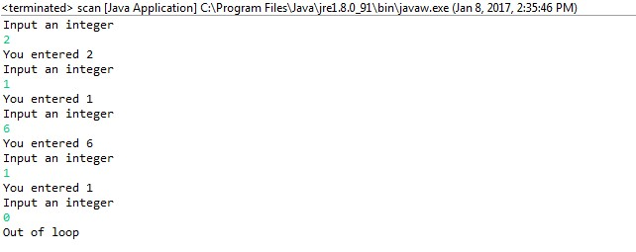

# 18. Print Star console using Loop

**class**

Stars

{

**public**

**static**

**void**

main

(

String

[]

args

)

{

**int**

row, numberOfStars

;

**for**

(

row

=

1

;

row

<=

10

;

row

++

)

{

**for**

(

numberOfStars

=

1

;

numberOfStars

<=

row

;

numberOfStars

++

)

{

System

.

out

.

print

(

"*"

)

;

}

System

.

out

.

println

()

;

*// Go to next line*

}

}

}

**19**

**.**

**While loop**

**Program in java**

**import**

java.util.Scanner

;

**class** WhileLoop {

**public** **static** **void** main(String[] args) { **int** n;

Scanner input = **new** Scanner(System.in); System.out.println("Input an integer");

**while** ((n = input.nextInt()) != 0) { System.out.println("You entered " + n);

System.out.println("Input an integer");

}

System.out.println("Out of loop");

}

## Automation Pro ficient

}

# 20. Print Reverse number in java program

**import** java.util.Scanner;

**class**

ReverseNumber

{

**public**

**static**

**void**

main

(

String

args

[])

{

**int**

n, reverse

=

0

;

System

.

out

.

println

(

"Enter the number to reverse"

)

;

Scanner in

=

**new**

Scanner

(

System

.

in

)

;

n

=

in.

nextInt

()

;

**while**

(

n

!=

0

)

{

reverse

=

reverse

*

10

;

reverse

=

reverse

+

n

%

10

;

n

=

n

/

10

;

}

System

.

out

.

println

(

"Reverse of entered number is "

+

reverse

)

;

}

}

# 21. While loop using break Program in java

**import**

java.util.Scanner

;

**class**

BreakWhileLoop

{

**public**

**static**

**void**

main

(

String

[]

args

)

{

**int**

n

;

Scanner input

=

**new**

Scanner

(

System

.

in

)

;

**while**

(

**true**

)

{

System

.

out

.

println

(

"Input an integer"

)

;

n

=

input.

nextInt

()

;

**if** (n == 0) { **break**;

}

System.out.println("You entered " + n);

}

}

}

## Automation Pro ficient

# 22. While loop using break and continue Program in java

**import**

java.util.Scanner

;

**class**

BreakContinueWhileLoop

{

**public**

**static**

**void**

main

(

String

[]

args

)

{

**int**

n

;

Scanner input

=

**new**

Scanner

(

System

.

in

)

;

**while**

(

**true**

)

{

System

.

out

.

println

(

"Input an integer"

)

;

n

=

input.

nextInt

()

;

**if**

(

n

!=

0

)

{

System

.

out

.

println

(

"You entered "

+

n

)

;

**continue**

;

}

**else**

{

**break**

;

}

}

}

}

# 23. Print all alphabet using for loop Program in java

**class** Alphabets

{

**public** **static** **void** main(String args[])

{ **char** ch;

**for**( ch = 'a' ; ch <= 'z' ; ch++ )

System.out.println(ch);

}

}

**Automation Pro ficient**

# 24. Enhance loop in java Program

**class** EnhancedForLoop {

**public** **static** **void** main(String[] args) {

**int** primes[] = { 2, 3, 5, 7, 11, 13, 17, 19, 23, 29};

**for** (**int** t: primes) { System.out.println(t);

}

}

}

**//For String**

**class**

EnhancedForLoop

{

**public**

**static**

**void**

main

(

String

[]

args

)

{

String

languages

[]

=

{

"C"

,

"C++"

,

"Java"

,

"Python"

,

"Ruby"

}

;

**for**

(

String

sample

:

languages

)

{

System

.

out

.

println

(

sample

)

;

}

}

}

# 25. Print Multiplication table Program in java

**import**

java.util.Scanner

;

**class**

MultiplicationTable

{

**public**

**static**

**void**

main

(

String

args

[])

{

**int**

n, c

;

System

.

out

.

println

(

"Enter an integer to print it's multiplication

table"

)

;

Scanner in

=

**new**

Scanner

(

System

.

in

)

;

n

=

in.

nextInt

()

;

System

.

out

.

println

(

"Multiplication table of "

+

n

+

" is :-"

)

;

**for**

(

c

=

1

;

c

<=

10

;

c

++

)

System

.

out

.

println

(

n

+

"*"

+

c

+

" = "

+

(

n

*

c

))

;

}

}

//For Any Number **import** java.util.Scanner;

**class** Tables

{

**public** **static** **void** main(String args[])

{

**int** a, b, c, d;

## Automation Pro ficient

System.out.println("Enter range of numbers to print their multiplication table");

Scanner in = **new** Scanner(System.in);

a = in.nextInt(); b = in.nextInt();

**for** (c = a; c <= b; c++) {

System.out.println("Multiplication table of "+c);

**for**

(

d

=

1

;

d

<=

10

;

d

++

)

{

System

.

out

.

println

(

c

+

"*"

+

d

+

" = "

+

(

c

*

d

))

;

}

}

}

}

# 26. Print prime no Program in java

**import**

java.util.*

;

**class**

PrimeNumbers

{

**public**

**static**

**void**

main

(

String

args

[])

{

**int**

n, status

=

1

, num

=

3

;

Scanner in

=

**new**

Scanner

(

System

.

in

)

;

System

.

out

.

println

(

"Enter the number of prime numbers you want"

)

;

n

=

in.

nextInt

()

;

**if**

(

n

>=

1

)

{

System

.

out

.

println

(

"First "

+

n

+

" prime numbers are :-"

)

;

System

.

out

.

println

(

2

)

;

}

**for**

(

**int**

count

=

2

;

count

<=

n

;

)

{

**for**

(

**int**

j

=

2

;

j

<=

Math

.

sqrt

(

num

)

;

j

++

)

{

**if**

(

num

%

j

==

0

)

{

status

=

0

;

**break**;

} }

**if** ( status != 0 )

{

System.out.println(num); count++;

}

## Automation Pro ficient

status = 1; num++;

}

}

}

# 27. Check no is Armstrong or not in java Program

**import**

java.util.Scanner

;

**class**

ArmstrongNumber

{

**public**

**static**

**void**

main

(

String

args

[])

{

**int**

n, sum

=

0

, temp, remainder, digits

=

0

;

Scanner in

=

**new**

Scanner

(

System

.

in

)

;

System

.

out

.

println

(

"Input a number to check if it is an Armstrong

number"

)

;

n

=

in.

nextInt

()

;

temp

=

n

;

*// Count number of digits*

**while**

(

temp

!=

0

)

{

digits

++

;

temp

=

temp

/

10

;

}

temp

=

n

;

**while**

(

temp

!=

0

)

{

remainder

=

temp

%

10

;

sum

=

sum

+

power

(

remainder, digits

)

;

temp

=

temp

/

10

;

}

**if**

(

n

==

sum

)

System

.

out

.

println

(

n

+

" is an Armstrong number."

)

;

**else**

System.out.println(n + " is not an Armstrong number.");

}

**static** **int** power(**int** n, **int** r) { **int** c, p = 1;

**for** (c = 1; c <= r; c++) p = p*n;

**return** p;

## f icient

}

}

# 28. Print Floyd’s Triangle in java Program

**import** java.util.Scanner;

**class**

FloydTriangle

{

**public**

**static**

**void**

main

(

String

args

[])

{

**int**

n, num

=

1

, c, d

;

Scanner in

=

**new**

Scanner

(

System

.

in

)

;

System

.

out

.

println

(

"Enter the number of rows of floyd's triangle you

want"

)

;

n

=

in.

nextInt

()

;

System

.

out

.

println

(

"Floyd's triangle :-"

)

;

**for**

(

c

=

1

;

c

<=

n

;

c

++

)

{

**for**

(

d

=

1

;

d

<=

c

;

d

++

)

{

System

.

out

.

print

(

num

+

" "

)

;

num

++

;

}

System

.

out

.

println

()

;

}

}

}

# 29. Find All substring of string in java Program

**import** java.util.Scanner; **class** SubstringsOfAString

{

**public** **static** **void** main(String args[])

{

String string, sub; **int** i, c, length;

Scanner in = **new** Scanner(System.in);

System.out.println("Enter a string to print it's all substrings"); string = in.nextLine();

length = string.length();

## Automation Pro ficient

System.out.println("Substrings of **\"**"+string+"**\"** are :-");

**for**( c = 0 ; c < length ; c++ )

{

**for**( i = 1 ; i <= length - c ; i++ )

{

sub = string.substring(c, c+i);

System.out.println(sub);

}

}

}

}

# 30. Print reverse string in java Program

**import** java.util.*;

**class**

ReverseString

{

**public**

**static**

**void**

main

(

String

args

[])

{

String

original, reverse

=

""

;

Scanner in

=

**new**

Scanner

(

System

.

in

)

;

System

.

out

.

println

(

"Enter a string to reverse"

)

;

original

=

in.

nextLine

()

;

**int**

length

=

original.

length

()

;

**for**

(

**int**

i

=

length

-

1

;

i

>=

0

;

i

--

)

reverse

=

reverse

+

original.

charAt

(

i

)

;

System

.

out

.

println

(

"Reverse of entered string is: "

+

reverse

)

;

}

}

//Using Internal java Methog

**class**

InvertString

{

**public**

**static**

**void**

main

(

String

args

[])

{

StringBuffer

a

=

**new**

StringBuffer

(

"Java programming is fun"

)

;

System

.

out

.

println

(

a.

reverse

())

;

}

}

# 31. Check Given No is palindrome or Not in java Program

**import** java.util.*;

**class** Palindrome

{

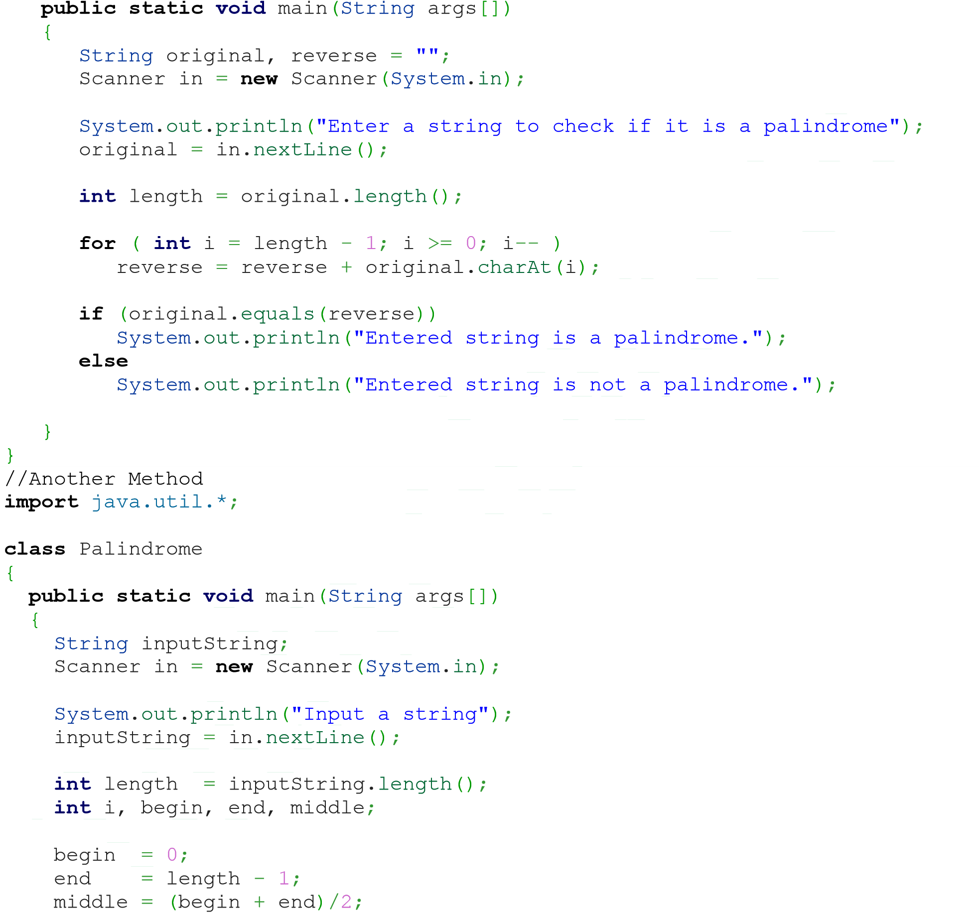

**for** (i = begin; i <= middle; i++) {

**if** (inputString.charAt(begin) == inputString.charAt(end)) { begin++; end--; } **else** { **break**;

}

}

**if** (i == middle + 1) {

System.out.println("Palindrome");

} **else** {

System.out.println("Not a palindrome");

}

}

}

# 32. How to add two matrix in java Program

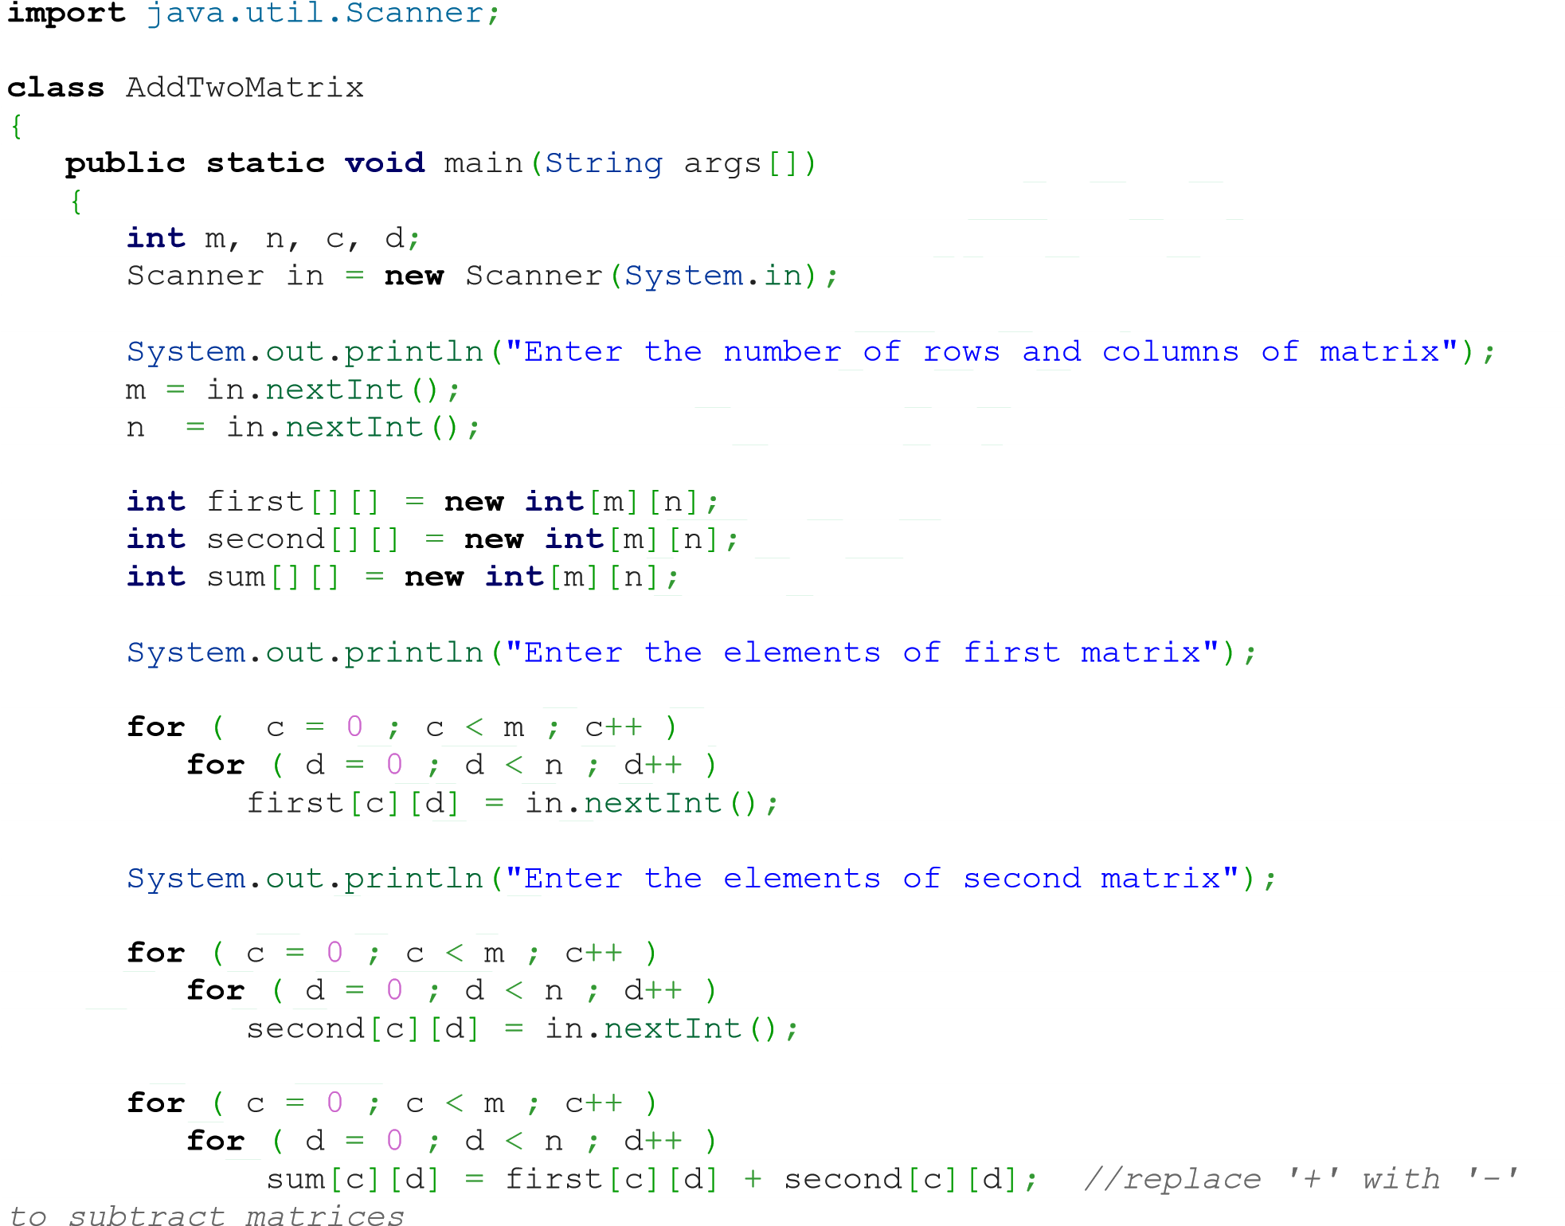

System.out.println("Sum of entered matrices:-");

**for** ( c = 0 ; c < m ; c++ )

{

**for** ( d = 0 ; d < n ; d++ ) System.out.print(sum[c][d]+"**\t**");

System.out.println();

}

}

}

# 33. How to multiply two matrix in java Program

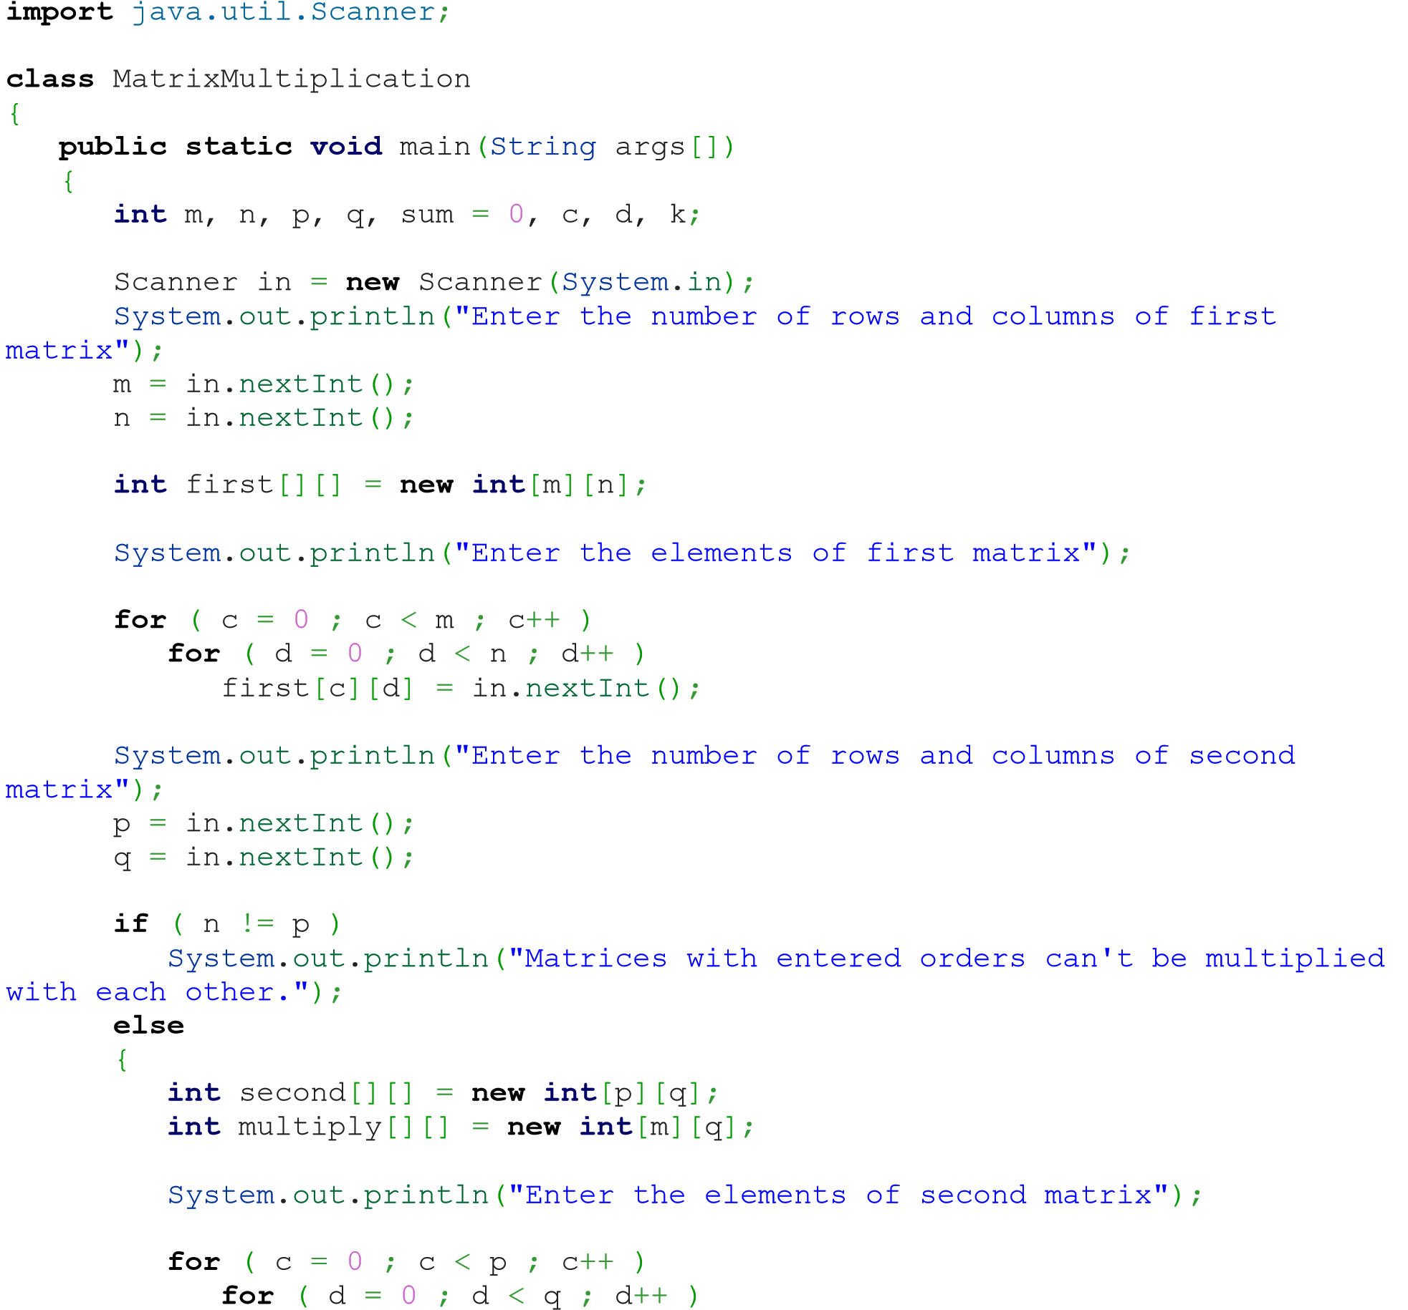

second[c][d] = in.nextInt();

**for** ( c = 0 ; c < m ; c++ )

{

**for** ( d = 0 ; d < q ; d++ )

{

**for** ( k = 0 ; k < p ; k++ )

{

sum = sum + first[c][k]*second[k][d];

}

multiply[c][d] = sum; sum = 0;

}

}

System.out.println("Product of entered matrices:-");

**for**

(

c

=

0

;

c

<

m

;

c

++

)

{

**for**

(

d

=

0

;

d

<

q

;

d

++

)

System

.

out

.

print

(

multiply

[

c

][

d

]

+

"

**\t**

"

)

;

System

.

out

.

print

(

"

**\n**

"

)

;

}

}

}

}

# 34. How to get transpose of matrix in java Program

**import** java.util.Scanner;

**class**

TransposeAMatrix

{

**public**

**static**

**void**

main

(

String

args

[])

{

**int**

m, n, c, d

;

Scanner in

=

**new**

Scanner

(

System

.

in

)

;

System

.

out

.

println

(

"Enter the number of rows and columns of matrix"

)

;

m

=

in.

nextInt

()

;

n

=

in.

nextInt

()

;

**int**

matrix

[][]

=

**new**

**int**

[

m

][

n

]

;

System

.

out

.

println

(

"Enter the elements of matrix"

)

;

**for**

(

c

=

0

;

c

<

m

;

c

++

)

**for**

(

d

=

0

;

d

<

n

;

d

++

)

matrix

[

c

][

d

]

=

in.

nextInt

()

;

**int** transpose[][] = **new** **int**[n][m];

**for** ( c = 0 ; c < m ; c++ )

{

**for** ( d = 0 ; d < n ; d++ ) transpose[d][c] = matrix[c][d]; }

System.out.println("Transpose of entered matrix:-");

**for** ( c = 0 ; c < n ; c++ )

{

**for** ( d = 0 ; d < m ; d++ )

System.out.print(transpose[c][d]+"**\t**");

System.out.print("**\n**");

}

}

}

# 35. How to compare 2 string in java Program

**public** **class** LastIndexOfExample{ **public** **static** **void** main(String args[]){

String s1="hello";

String s2="hello";

String s3="meklo";

String s4="hemlo";

System.***out***.println(s1.compareTo(s2));

System.***out***.println(s1.compareTo(s3));

System.***out***.println(s1.compareTo(s4)); }}

# 36. How to string width with specific char in java Program

**class** StringEndwith{

**public** **static** **void** main(String args[]){ String s1="java by TechnoLamror";

System.***out***.println(s1.endsWith("r")); //true

System.***out***.println(s1.endsWith("Lamror")); //true

System.***out***.println(s1.endsWith("lamror"));//false

}

}

# 37. How to use indesOf() in java Program

**public** **class** IndexOfExample{ **public** **static** **void** main(String args[]){

String s1="this is index of example";

//passing substring

**int** index1=s1.indexOf("is");//returns the index of is substring **int** index2=s1.indexOf("index");//returns the index of index substring

System.***out***.println(index1+" "+index2);//2 8

//passing substring with from index

**int** index3=s1.indexOf("is",4);//returns the index of is substring after 4th index

System.***out***.println(index3);//5 i.e. the index of another is

//passing char value

**int** index4=s1.indexOf('s');//returns the index of s char value

}} System.***out***.println(index4);//3

# 38. How to replace string with another string in java Program

**public** **class** ReplaceAllExample2{ **public** **static** **void** main(String args[]){

String s1="My name is Rajendra. My name is lamror. My name is Technolamror.";

String replaceString=s1.replaceAll("is","was");//replaces all occurrences of "is" to "was"

System.***out***.println(replaceString); }}

# 39. How to split string in java Program

**public** **class** SplitExample{

**public** **static** **void** main(String args[]){

String s1="java string split method by Technolamror";

String[] words=s1.split("\\s");//splits the string based on whitespace

//using java foreach loop to print elements of string array **for**(String w:words){ System.***out***.println(w);

}

}}

# 40. How to remove space in string both end in java Program

**public** **class** StringTrimExample{ **public** **static** **void** main(String args[]){

String s1=" hello string ";

System.***out***.println(s1+"Technolamror");//without trim()

System.***out***.println(s1.trim()+"Technolamror");//with trim() }}

# 41. How to convert all char in string lower case in java Program

**public** **class** StringLowerExample{ **public** **static** **void** main(String args[]){

String s1="TECHNOLAMROR by Rajendralamror HELLO stRIng";

String s1lower=s1.toLowerCase();

## Automation Prof icient

}} System.***out***.println(s1lower);

# 42. How to create method in java Program

**class** Methods {

*// Constructor method*

Methods

()

{

System

.

out

.

println

(

"Constructor method is called when an object of it's

class is created"

)

;

}

*// Main method where program execution begins*

**public**

**static**

**void**

main

(

String

[]

args

)

{

staticMethod

()

;

Methods object

=

**new**

Methods

()

;

object.

nonStaticMethod

()

;

}

*// Static method*

**static**

**void**

staticMethod

()

{

System

.

out

.

println

(

"Static method can be called without creating

object"

)

;

}

*// Non static method*

**void**

nonStaticMethod

()

{

System

.

out

.

println

(

"Non static method must be called by creating an

object"

)

;

}

}

# 43. Find Length, Concatenate and Replace String in Java Program

**class** StringMethods

{

**public** **static** **void** main(String args[])

{ **int** n;

String s = "Java programming", t = "", u = "";

System.out.println(s);

*// Find length of string*

n = s.length();

System.out.println("Number of characters = " + n);

*// Replace characters in string*

t = s.replace("Java", "C++");

System.out.println(s);

System.out.println(t);

*// Concatenating string with another string*

u

=

s.

concat

(

" is fun"

)

;

System

.

out

.

println

(

s

)

;

System

.

out

.

println

(

u

)

;

}

}

# 44. How Static block working in java Program

**class**

StaticBlock

{

**public**

**static**

**void**

main

(

String

[]

args

)

{

System

.

out

.

println

(

"Main method is executed."

)

;

}

**static**

{

System

.

out

.

println

(

"Static block is executed before main method."

)

;

}

}

//Static Block

Application …. We need to open Program in speciif window

**class**

StaticBlock

{

**public**

**static**

**void**

main

(

String

[]

args

)

{

System

.

out

.

println

(

"You are using Windows_NT operating system."

)

;

}

**static**

{

String

os

=

System

.

getenv

(

"OS"

)

;

**if**

(

os.

equals

(

"Windows_NT"

)

!=

**true**

)

{

System

.

exit

(

1

)

;

}

}

}

# 45. Difference between Static and Instance method working in java Program

**class** Difference {

**public** **static** **void** main(String[] args) { display(); *//calling without object*

## ficient

Difference t = **new** Difference();

t.show(); *//calling using object*

}

**static** **void** display() {

System.out.println("Programming is amazing.");

} **void** show(){

System.out.println("Java is awesome.");

}

}

# 46. How to create Multiple class in java Program

**class** Computer {

Computer() {

System.out.println("Constructor of Computer class."); }

**void**

computer_method

()

{

System

.

out

.

println

(

"Power gone! Shut down your PC soon..."

)

;

}

**public**

**static**

**void**

main

(

String

[]

args

)

{

Computer my

=

**new**

Computer

()

;

Laptop your

=

**new**

Laptop

()

;

my.

computer_method

()

;

your.

laptop_method

()

;

}

}

**class**

Laptop

{

Laptop

()

{

System

.

out

.

println

(

"Constructor of Laptop class."

)

;

}

**void**

laptop_method

()

{

System

.

out

.

println

(

"99% Battery available."

)

;

}

}

# 47. How to create constructor in java Program

**class** Programming {

*//constructor method*

Programming() {

System.out.println("Constructor method called.");

}

**public** **static** **void** main(String[] args) {

Programming object = **new** Programming(); *//creating object*

}

}

# 48. How to create constructor overloading in

**java Program**

**class**

Language

{

String

name

;

Language

()

{

System

.

out

.

println

(

"Constructor method called."

)

;

}

Language

(

String

t

)

{

name

=

t

;

}

**public**

**static**

**void**

main

(

String

[]

args

)

{

Language cpp

=

**new**

Language

()

;

Language java

=

**new**

Language

(

"Java"

)

;

cpp.

setName

(

"C++"

)

;

java.

getName

()

;

cpp.

getName

()

;

}

**void**

setName

(

String

t

)

{

name

=

t

;

}

**void**

getName

()

{

System

.

out

.

println

(

"Language name: "

+

name

)

;

}

}

# 49. Exception Handling java Program

**class** Division {

**public** **static** **void** main(String[] args) {

**int** a, b, result;

Scanner input = **new** Scanner(System.in);

System.out.println("Input two integers");

## ficient

a = input.nextInt(); b = input.nextInt();

*// try block*

**try** {

result = a / b;

System.out.println("Result = " + result);

}

*// catch block*

**catch**

(

ArithmeticException

e

)

{

System

.

out

.

println

(

"Exception caught: Division by zero."

)

;

}

}

}

# 50. How to throw exception in java Program

**public** **class** TestThrow1{ **static** **void** validate(**int** age){ **if**(age<18)

**throw** **new** ArithmeticException("not valid"); **else**

System.***out***.println("welcome to vote on Technolamror");

}

**public** **static** **void** main(String args[]){ *validate*(13);

System.***out***.println("rest of the code...");

}

}

# 51. Advantage of Finally in Exception Handling java Program

**class** Allocate {

**public** **static** **void** main(String[] args) {

**try** {

**long** data[] = **new** **long**[1000000000];

}

**catch** (Exception e) {

System.out.println(e);

} **finally** {

System.out.println("finally block will execute always.");

}

}

}

# 52. How to create Interface in java Program

**interface** Info {

**static** **final** String language = "Java"; **public** **void** display();

}

**class**

Simple

**implements**

Info

{

**public**

**static**

**void**

main

(

String

[]

args

)

{

Simple obj

=

**new**

Simple

()

;

obj.

display

()

;

}

*// Defining method declared in interface*

**public**

**void**

display

()

{

System

.

out

.

println

(

language

+

" is awesome"

)

;

}

}

# 53. How to print date and time in java Program

**public** **class** SQLDateExample {

**public** **static** **void** main(String[] args) { **long** millis=System.*currentTimeMillis*(); java.sql.Date date=**new** java.sql.Date(millis);

System.***out***.println(date);

}

}

/// Another Way

**import**

java.util.*

;

**class**

GetCurrentDateAndTime

{

**public**

**static**

**void**

main

(

String

args

[])

{

**int**

day, month, year

;

**int**

second, minute, hour

;

GregorianCalendar

date

=

**new**

GregorianCalendar

()

;

day = date.get(Calendar.DAY_OF_MONTH); month = date.get(Calendar.MONTH); year = date.get(Calendar.YEAR);

second = date.get(Calendar.SECOND); minute = date.get(Calendar.MINUTE); hour = date.get(Calendar.HOUR);

## Automation Pro ficient

System.out.println("Current date is "+day+"/"+(month+1)+"/"+year);

System.out.println("Current time is "+hour+" : "+minute+" : "+second);

}

}

# 54. How to SQL Date in java Program

**import** java.sql.Date;

**public** **class** StringToSQLDateExample { **public** **static** **void** main(String[] args) {

String str="2015-03-31";

Date date=Date.valueOf(str);//converting string into sql date

System.out.println(date);

} }

# 55. How to Date format in java Program

**import** java.text.ParseException; **import** java.text.SimpleDateFormat; **import** java.util.Date; **import** java.util.Locale;

**public** **class** SimpleDateFormatExample2 { **public** **static** **void** main(String[] args) {

Date date = **new** Date();

System.***out***.println("Date formate chnage by Technolamror ");

SimpleDateFormat formatter = **new** SimpleDateFormat("MM/dd/yyyy");

String strDate = formatter.format(date);

System.***out***.println("Date Format with MM/dd/yyyy : "+strDate);

formatter = **new** SimpleDateFormat("dd-M-yyyy hh:mm:ss");

strDate = formatter.format(date);

System.***out***.println("Date Format with dd-M-yyyy hh:mm:ss : "+strDate);

formatter = **new** SimpleDateFormat("dd MMMM yyyy");

strDate = formatter.format(date);

System.***out***.println("Date Format with dd MMMM yyyy : "+strDate);

formatter = **new** SimpleDateFormat("dd MMMM yyyy zzzz"); strDate = formatter.format(date);

System.***out***.println("Date Format with dd MMMM yyyy zzzz : "+strDate);

formatter = **new** SimpleDateFormat("E, dd MMM yyyy HH:mm:ss z");

strDate = formatter.format(date);

System.***out***.println("Date Format with E, dd MMM yyyy HH:mm:ss z : "+strDate);

} }

# 56. How to Generate random number in java Program

**import** java.util.*;

**class** RandomNumbers {

**public** **static** **void** main(String[] args) { **int** c;

Random

t

=

**new**

Random

()

;

*// random integers in [0, 100]*

**for**

(

c

=

1

;

c

<=

10

;

c

++

)

{

System

.

out

.

println

(

t.

nextInt

(

100

))

;

}

}

}

# 57. How perform garbage collection in java Program

**import**

java.util.*

;

**class**

GarbageCollection

{

**public**

**static**

**void**

main

(

String

s

[])

**throws**

Exception

{

Runtime

rs

=

Runtime

.

getRuntime

()

;

System

.

out

.

println

(

"Free memory in JVM before Garbage Collection =

"

+

rs.

freeMemory

())

;

rs.

gc

()

;

System

.

out

.

println

(

"Free memory in JVM after Garbage Collection =

"

+

rs.

freeMemory

())

;

}

}

# 58. How to get own IP Address in java Program

**import** java.net.InetAddress;

**class** IPAddress

{

**public** **static** **void** main(String args[]) **throws** Exception {

System.out.println(InetAddress.getLocalHost());

}

}

## Automation Prof icient

# 59. How to open notepad in java Program

**import** java.util.*; **import** java.io.*;

**class**

Notepad

{

**public**

**static**

**void**

main

(

String

[]

args

)

{

Runtime

rs

=

Runtime

.

getRuntime

()

;

**try**

{

rs.

exec

(

"notepad"

)

;

}

**catch**

(

IOException

e

)

{

System

.

out

.

println

(

e

)

;

}

}

}

# 60. Leaner search Program in java

System.out.println("Enter value to find"); search = in.nextInt();

**import**

java.util.Scanner

;

**class**

LinearSearch

{

**public**

**static**

**void**

main

(

String

args

[])

{

**int**

c, n, search, array

[]

;

Scanner in

=

**new**

Scanner

(

System

.

in

)

;

System

.

out

.

println

(

"Enter number of elements"

)

;

n

=

in.

nextInt

()

;

array

=

**new**

**int**

[

n

]

;

System

.

out

.

println

(

"Enter "

+

n

+

" integers"

)

;

**for**

(

c

=

0

;

c

<

n

;

c

++

)

array

[

c

]

=

in.

nextInt

()

;

**for** (c = 0; c < n; c++)

{

**if** (array[c] == search) */* Searching element is present */* {

System.out.println(search + " is present at location " + (c + 1) +

"."); **break**;

}

}

**if** (c == n) */* Searching element is absent */*

System.out.println(search + " is not present in array.");

}

}

# 61. Binary search Program in java

**import** java.util.Scanner;

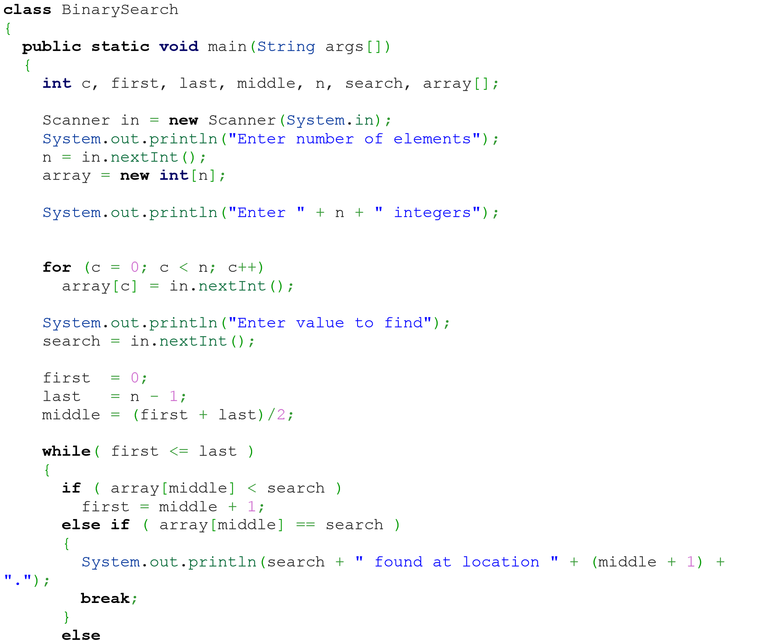

last = middle - 1;

middle = (first + last)/2;

}

**if** ( first > last )

System.out.println(search + " is not present in the list.**\n**"); }

}

## Automation Pro ficient

# 62. Bubble sort Program in java

**import** java.util.Scanner;

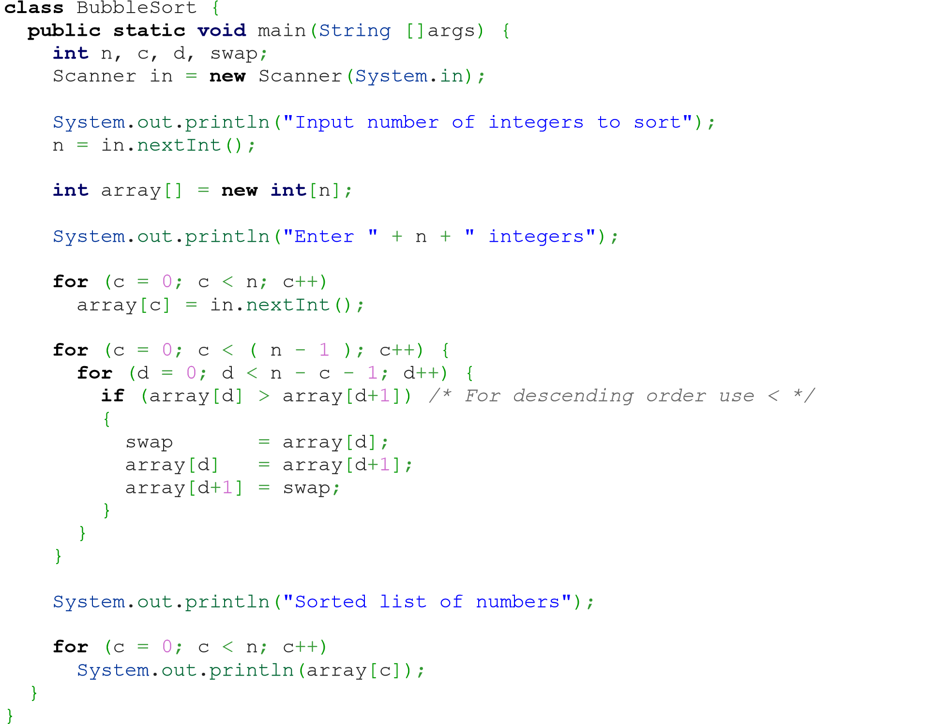

# 63. How to connect Database using java Program

**import** java.sql.*; **class** OracleCon{

**public** **static** **void** main(String args[]){ **try**{

//step1 load the driver class

Class.*forName*("oracle.jdbc.driver.OracleDriver");

//step2 create the connection object

Connection

con=DriverManager.*getConnection*("jdbc:oracle:thin:@localhost:1521:xe","system","oracl e");

//step3 create the statement object

Statement stmt=con.createStatement();

//step4 execute query

ResultSet rs=stmt.executeQuery("select * from emp"); **while**(rs.next())

System.***out***.println(rs.getInt(1)+" "+rs.getString(2)+" "+rs.getString(3));

//step5 close the connection object con.close();

}**catch**(Exception e){ System.***out***.println(e);}

}

}

# 64. How to insert data in table using JDBC in java Program

**import** java.sql.*; **class** InsertPrepared{

**public** **static** **void** main(String args[]){ **try**{

Class.*forName*("oracle.jdbc.driver.OracleDriver"); Connection

con=DriverManager.*getConnection*("jdbc:oracle:thin:@localhost:1521:xe","system","oracl e");

PreparedStatement stmt=con.prepareStatement("insert into Emp values(?,?)"); stmt.setInt(1,101);//1 specifies the first parameter in the query stmt.setString(2,"Ratan"); **int** i=stmt.executeUpdate();

System.***out***.println(i+" records inserted"); con.close();

}**catch**(Exception e){ System.***out***.println(e);}

}

}

# 65. How to insert image using JDBC in java Program

**import** java.sql.*; **import** java.io.*; **public** **class** InsertImage { **public** **static** **void** main(String[] args) { **try**{

Class.*forName*("oracle.jdbc.driver.OracleDriver");

Connection con=DriverManager.*getConnection*(

"jdbc:oracle:thin:@localhost:1521:xe","system","oracle");

PreparedStatement ps=con.prepareStatement("insert into imgtable values(?,?)");

## Automation Proficient

ps.setString(1,"Technolamror");

FileInputStream fin=**new** FileInputStream("d:\\g.jpg"); ps.setBinaryStream(2,fin,fin.available()); **int** i=ps.executeUpdate();

System.***out***.println(i+" records affected"); con.close();

}**catch** (Exception e) {e.printStackTrace();}

}

}

# 66. How to execute Procedure in JDBC in java Program

**import** java.sql.*; **public** **class** Proc {

**public** **static** **void** main(String[] args) **throws** Exception{

Class.*forName*("oracle.jdbc.driver.OracleDriver"); Connection

con=DriverManager.*getConnection*("jdbc:oracle:thin:@localhost:1521:xe","system","oracl e");

CallableStatement stmt=con.prepareCall("{call insertR(?,?)}"); stmt.setInt(1,1011); stmt.setString(2,"Amit"); stmt.execute();

System.***out***.println("success");

}

}

# 67. How to check Regular expression in java Program

**import** java.util.regex.*; **public** **class** RegexExample1{

**public** **static** **void** main(String args[]){

//1st way

Pattern p = Pattern.*compile*(".s");//. represents single character

Matcher m = p.matcher("as"); **boolean** b = m.matches();

//2nd way

**boolean** b2=Pattern.*compile*(".s").matcher("as").matches();

//3rd way

**boolean** b3 = Pattern.*matches*(".s", "as");

System.***out***.println(b+" "+b2+" "+b3); }}

# 68. How to create Multithreading program in java

**class** Multi **extends** Thread{ **public** **void** run(){

System.***out***.println("thread is running...");

}

**public** **static** **void** main(String args[]){

Multi t1=**new** Multi(); t1.start();

} }

# 69. How to join thread in java program

**class** TestJoinMethod1 **extends** Thread{ **public** **void** run(){ **for**(**int** i=1;i<=5;i++){ **try**{

Thread.*sleep*(500);

}**catch**(Exception e){System.***out***.println(e);}

System.***out***.println(i);

} } **public** **static** **void** main(String args[]){ TestJoinMethod1 t1=**new** TestJoinMethod1();

TestJoinMethod1 t2=**new** TestJoinMethod1(); TestJoinMethod1 t3=**new** TestJoinMethod1(); t1.start(); **try**{ t1.join();

}**catch**(Exception e){System.***out***.println(e);}

t2.start(); t3.start();

}

}

# 70. How to write data in text file using java program

**import** java.io.FileOutputStream; **public** **class** FileOutputStreamExample { **public** **static** **void** main(String args[]){ **try**{

FileOutputStream fout=**new** FileOutputStream("D:\\testout.txt"); fout.write(65); fout.close();

System.***out***.println("success.. by Technolamror.");

}**catch**(Exception e){System.***out***.println(e);}

}

}

# 71. How to read data from text file using java program

**import** java.io.FileInputStream; **public** **class** DataStreamExample {

**public** **static** **void** main(String args[]){

**try**{

FileInputStream fin=**new** FileInputStream("D:\\Technolamror.txt"); **int** i=fin.read();

System.***out***.print((**char**)i);

fin.close();

}**catch**(Exception e){System.***out***.println(e);}

} }

# 72. How to get URL of site using java Programs

**import** java.io.*; **import** java.net.*; **public** **class** URLDemo{

**public** **static** **void** main(String[] args){ **try**{

URL url=**new** URL("http://www.technolamror.com/java");

System.***out***.println("Protocol: "+url.getProtocol());

System.***out***.println("Host Name: "+url.getHost());

System.***out***.println("Port Number: "+url.getPort());

System.***out***.println("File Name: "+url.getFile());

}**catch**(Exception e){System.***out***.println(e);}

}

}

# 73. How to get IP address from site URL using java program

**import** java.io.*; **import** java.net.*; **public** **class** InetDemo{

**public** **static** **void** main(String[] args){ **try**{

InetAddress ip=InetAddress.*getByName*("www.Technolamror.com");

System.***out***.println("Host Name: "+ip.getHostName());

System.***out***.println("IP Address: "+ip.getHostAddress());

}**catch**(Exception e){System.***out***.println(e);}

} }

# 74. How to create AWT program in java

**import** java.awt.*; **class** First **extends** Frame{

First(){

Button b=**new** Button("click me");

b.setBounds(30,100,80,30);// setting button position

add(b);//adding button into frame

setSize(300,300);//frame size 300 width and 300 height setLayout(**null**);//no layout manager

setVisible(**true**);//now frame will be visible, by default not visible

} **public** **static** **void** main(String args[]){

}} First f=**new** First();

# 75. How to add lable in AWT program in java

**import** java.awt.*; **class** LabelExample{

**public** **static** **void** main(String args[]){

Frame f= **new** Frame("Label Example by Technolamror"); Label l1,l2;

l1=**new** Label("First Label."); l1.setBounds(50,100, 100,30); l2=**new** Label("Second Label."); l2.setBounds(50,150, 100,30);

f.add(l1); f.add(l2);

f.setSize(400,400);

f.setLayout(**null**);

f.setVisible(**true**);

} }

# 76. How to add text area program in java

**import** java.awt.*; **public** **class** TextAreaExample

{

TextAreaExample(){

Frame f= **new** Frame();

TextArea area=**new** TextArea("Welcome to Technolamror"); area.setBounds(10,30, 300,300);

f.add(area);

f.setSize(400,400);

f.setLayout(**null**);

f.setVisible(**true**); }

**public** **static** **void** main(String args[])

{

**new** TextAreaExample();

}

}

# 77. How to dropdown in AWT program in java

**import** java.awt.*; **public** **class** ChoiceExample

{

ChoiceExample(){

Frame f= **new** Frame(); Choice c=**new** Choice();

c.setBounds(100,100, 75,75);

c.add("Item 1 by Rajendra");

c.add("Item 2 by Lamror");

c.add("Item 3 by Technolamror");

c.add("Item 4");

c.add("Item 5");

f.add(c);

f.setSize(400,400);

f.setLayout(**null**);

f.setVisible(**true**); }

**public** **static** **void** main(String args[])

{

**new** ChoiceExample();

}

}

# 78. How to create Swing program in java

**import** javax.swing.*; **public** **class** FirstSwingExample { **public** **static** **void** main(String[] args) {

JFrame f=**new** JFrame();//creating instance of JFrame JButton b=**new** JButton("click");//creating instance of JButton

b.setBounds(130,100,100, 40);//x axis, y axis, width, height

f.add(b);//adding button in JFrame

f.setSize(400,500);//400 width and 500 height

f.setLayout(**null**);//using no layout managers

f.setVisible(**true**);//making the frame visible

}

}

# 79. How to add checkbox in Swing program in java

**import** javax.swing.*; **public** **class** CheckBoxExample

{

CheckBoxExample(){

JFrame f= **new** JFrame("CheckBox Example by Technolamror");

JCheckBox checkBox1 = **new** JCheckBox("C++"); checkBox1.setBounds(100,100, 50,50);

JCheckBox checkBox2 = **new** JCheckBox("Java", **true**); checkBox2.setBounds(100,150, 50,50);

f.add(checkBox1);

f.add(checkBox2);

f.setSize(400,400);

f.setLayout(**null**);

f.setVisible(**true**); }

**public** **static** **void** main(String args[])

{ }} **new** CheckBoxExample();

# 80. How to convert string to integer in java program

**public** **class** StringToIntExample{ **public** **static** **void** main(String args[]){ String s="200";

**int** i=Integer.*parseInt*(s);

System.***out***.println(s+100);//200100 because + is string concatenation operator

}} System.***out***.println(i+100);//300 because + is binary plus operator

# 81. How to convert integer to string in java program

**public** **class** IntToStringExample1{ **public** **static** **void** main(String args[]){

**int** i=200;

String s=String.*valueOf*(i);

System.***out***.println(i+100);//300 because + is binary plus operator

}} System.***out***.println(s+100);//200100 because + is string concatenation operator

# 82. How to convert string to long in java

**public** **class** StringToLongExample{ **public** **static** **void** main(String args[]){ String s="9990449935"; **long** l=Long.*parseLong*(s);

}} System.***out***.println(l);

# 83. How to convert string to float in java

**public** **class** StringToFloatExample{ **public** **static** **void** main(String args[]){ String s="23.6";

**float** f=Float.*parseFloat*("23.6");

}} System.***out***.println(f);

# 84. How to convert string to double in java program

**public** **class** StringToDoubleExample{

**public** **static** **void** main(String args[]){

String s="23.6";

**double** d=Double.*parseDouble*("23.6");

System.***out***.println(d); ;

}

}

# 85. How to convert string to date in java program

**import** java.text.SimpleDateFormat; **import** java.util.Date; **public** **class** StringToDateExample1 {

**public** **static** **void** main(String[] args)**throws** Exception {

String sDate1="31/12/1998";

String sDate2 = "31-Dec-1998";

String sDate3 = "12 31, 1998";

String sDate4 = "Thu, Dec 31 1998";

String sDate5 = "Thu, Dec 31 1998 23:37:50";

String sDate6 = "31-Dec-1998 23:37:50";

SimpleDateFormat formatter1=**new** SimpleDateFormat("dd/MM/yyyy");

SimpleDateFormat formatter2=**new** SimpleDateFormat("dd-MMM-yyyy");

SimpleDateFormat formatter3=**new** SimpleDateFormat("MM dd, yyyy");

SimpleDateFormat formatter4=**new** SimpleDateFormat("E, MMM dd yyyy");

SimpleDateFormat formatter5=**new** SimpleDateFormat("E, MMM dd yyyy HH:mm:ss");

SimpleDateFormat formatter6=**new** SimpleDateFormat("dd-MMM-yyyy HH:mm:ss");

Date date1=formatter1.parse(sDate1);

Date date2=formatter2.parse(sDate2);

Date date3=formatter3.parse(sDate3);

Date date4=formatter4.parse(sDate4);

Date date5=formatter5.parse(sDate5);

Date date6=formatter6.parse(sDate6);

System.***out***.println("String to Date converter by technolamror");

System.***out***.println(sDate1+"\t"+date1);

System.***out***.println(sDate2+"\t"+date2);

System.***out***.println(sDate3+"\t"+date3);

System.***out***.println(sDate4+"\t"+date4);

System.***out***.println(sDate5+"\t"+date5);

System.***out***.println(sDate6+"\t"+date6);

}

}

# 86. Create ArrayList program in java

**import** java.util.*; **class** Arrylist_Technolamror{

**public** **static** **void** main(String args[]){

ArrayList<String> list=**new** ArrayList<String>();//Creating arraylist list.add("Rajendra");//Adding object in arraylist list.add("Mahendra"); list.add("Raja"); list.add("Technolamror");

//Traversing list through Iterator Iterator itr=list.iterator(); **while**(itr.hasNext()){

System.***out***.println(itr.next()); }

}

}

# 87. How to create LinkedList program in java

**import** java.util.*;

**public** **class** LinkedList_technolamror{ **public** **static** **void** main(String args[]){

Linkedal<String> al=**new** Linkedal<String>();

al.add("Rajendra");//Adding object in LinkedList al.add("Mahendra"); al.add("Raja"); al.add("Technolamror");

Iterator<String> itr=al.iterator(); **while**(itr.hasNext()){

System.***out***.println(itr.next()); }

}

}

# 88. How to ArrayList using list interface program in java

**import** java.util.*; **class** Book { **int** id;

String name,author,publisher; **int** quantity;

**public** Book(**int** id, String name, String author, String publisher, **int** quantity) { **this**.id = id; **this**.name = name; **this**.author = author; **this**.publisher = publisher; **this**.quantity = quantity;

} } **public** **class** ListIteratorExample { **public** **static** **void** main(String[] args) {

//Creating list of Books

List<Book> list=**new** ArrayList<Book>();

//Creating Books

Book b1=**new** Book(101,"Let us C","Yashwant Kanetkar","BPB",8);

Book b2=**new** Book(102,"Java Program Questation","Rajendra","Technolamror",4);

Book b3=**new** Book(103,"Operating System","Galvin","Wiley",6);

//Adding Books to list

list.add(b1); list.add(b2); list.add(b3);

System.***out***.println("Original content of list is: ");

//Traversing list **for**(Book b:list){

System.***out***.println(b.id+" "+b.name+" "+b.author+" "+b.publisher+" "+b.quantity); }

ListIterator<Book> itr=list.listIterator();

System.***out***.println("Modified content of list in backward is: "); **while**(itr.hasNext()){ Book st=(Book)itr.next();

System.***out***.println(st.quantity+" "+st.publisher+" "+st.author+" "+st.name+"

"+st.id);

}

}

}

# 89. How to create Hashset program in java

**import** java.util.*; **class** TestCollection9{

**public** **static** **void** main(String args[]){ //Creating HashSet and adding elements HashSet<String> set=**new** HashSet<String>(); set.add("Rajendra"); set.add("Raja"); set.add("Ravi"); set.add("Technolamror");

//Traversing elements

Iterator<String> itr=set.iterator(); **while**(itr.hasNext()){

System.***out***.println(itr.next()); }

}

}

# 90. How to create LinkedHashSet program in java

**import** java.util.*;

**class** LinkedHashSet_Technolamror{ **public** **static** **void** main(String args[]){

LinkedHashSet<String> al=**new** LinkedHashSet<String>();

al.add("Rajendra"); al.add("Raja"); al.add("Ravi"); al.add("Technolamror");

Iterator<String> itr=al.iterator(); **while**(itr.hasNext()){

***out*** itr

}

}

}

# 91. How to create TreeSet program in java

**import** java.util.*; **class** TreeSet_Technolamror{

**public** **static** **void** main(String args[]){ //Creating and adding elements

TreeSet<String> al=**new** TreeSet<String>(); al.add("Rajendra"); al.add("Raja"); al.add("Ravi");

al.add("Technolamror"); ments Iterator<String> itr=al.iterator(); **while**(itr.hasNext()){

System.***out***.println(itr.next()); }

}

}

# 92. How to create PriorityQueue program in java

**import** java.util.*; **class** PriorityQueue_Technolamror{ **public** **static** **void** main(String args[]){

PriorityQueue<String> queue=**new** PriorityQueue<String>(); queue.add("Rajendra"); queue.add("Mahendra"); queue.add("Raja"); queue.add("Technolamror"); queue.add("Rahul");

System.***out***.println("head:"+queue.element());

System.***out***.println("head:"+queue.peek());

System.***out***.println("iterating the queue elements:");

Iterator itr=queue.iterator(); **while**(itr.hasNext()){

System.***out***.println(itr.next());

} queue.remove(); queue.poll();

System.***out***.println("after removing two elements:");

Iterator<String> itr2=queue.iterator();

**while**(itr2.hasNext()){

System.***out***.println(itr2.next());

}

}

}

# 93. How to create HashMap using map interface program in java

**import** java.util.*; **class** MapInterfaceExample{

**public** **static** **void** main(String args[]){

Map<Integer,String> map=**new** HashMap<Integer,String>(); map.put(100,"Rajendra"); map.put(101,"Lamror"); map.put(102,"Technolamror"); **for**(Map.Entry m:map.entrySet()){

System.***out***.println(m.getKey()+" "+m.getValue()); }

}

}

# 94. How to create LinkedHashMap program in java

**import** java.util.*; **class** LinkedHashMap_Technolmaror{ **public** **static** **void** main(String args[]){

LinkedHashMap<Integer,String> hm=**new** LinkedHashMap<Integer,String>();

hm.put(100,"Rajendra"); hm.put(101,"Vijay"); hm.put(102,"Technolamror");

**for**(Map.Entry m:hm.entrySet()){

System.***out***.println(m.getKey()+" "+m.getValue()); }

}

}

# 95. How to create TreeMap program in java

**import** java.util.*; **class** TreeMap_Technolamror{

**public** **static** **void** main(String args[]){

TreeMap<Integer,String> hm=**new** TreeMap<Integer,String>(); hm.put(100,"Amit"); hm.put(102,"Ravi"); hm.put(101,"Vijay"); hm.put(103,"Technolamror"); **for**(Map.Entry m:hm.entrySet()){

System.***out***.println(m.getKey()+" "+m.getValue());

}

}

}

# 96. How to create Hashtable program in java

**import** java.util.*; **class** Hashtable_Technolamror{ **public** **static** **void** main(String args[]){

Hashtable<Integer,String> hm=**new** Hashtable<Integer,String>();

hm.put(100,"Rajendra"); hm.put(102,"Praveen"); hm.put(101,"Bipin"); hm.put(103,"Pankaj");

**for**(Map.Entry m:hm.entrySet()){

System.***out***.println(m.getKey()+" "+m.getValue()); }

}

}

# 97. How to create Array program in java

**class** Array_Technolamror{

**public** **static** **void** main(String args[]){

**int** a[]=**new** **int**[5];//declaration and instantiation a[0]=10;//initialization a[1]=20; a[2]=70; a[3]=40; a[4]=50;

//printing array

**for**(**int** i=0;i<a.length;i++)//length is the property of array System.***out***.println(a[i]);

}}

# 98. How to create Multidimensional array program in java

**class** Multi_Array{

**public** **static** **void** main(String args[]){

//declaring and initializing 2D array **int** arr[][]={{1,2,3},{2,4,5},{4,4,5}};

//printing 2D array **for**(**int** i=0;i<3;i++){ **for**(**int** j=0;j<3;j++){

System.***out***.print(arr[i][j]+" ");

}

System.***out***.println();

}

}}

# 99. How to create Find Factorial No using Recursion Program in java

**public** **class** Recursion_Technolamror { **static** **int** factorial(**int** n){ **if** (n == 1) **return** 1; **else**

**return**(n * *factorial*(n-1));

}

**public** **static** **void** main(String[] args) {

System.***out***.println("Factorial of 5 is: "+*factorial*(5));

} }

# 100. How to create Method Overriding program in java

**class** Bank{

**int** getRateOfInterest(){**return** 0;}

}

**class** SBI **extends** Bank{ **int** getRateOfInterest(){**return** 8;}

}

**class** ICICI **extends** Bank{ **int** getRateOfInterest(){**return** 7;}

}

**class** AXIS **extends** Bank{ **int** getRateOfInterest(){**return** 9;}

} **class** Test2{

**public** **static** **void** main(String args[]){

SBI s=**new** SBI();

ICICI i=**new** ICICI();

AXIS a=**new** AXIS();

System.***out***.println("SBI Rate of Interest: "+s.getRateOfInterest());

System.***out***.println("ICICI Rate of Interest: "+i.getRateOfInterest());

System.***out***.println("AXIS Rate of Interest: "+a.getRateOfInterest()); } }